Lab 7: Recycle Bin and Anti-forensics
What You Need for this lab
  - Install Virtualbox : https://www.virtualbox.org/wiki/Downloads
  - Install Kali 2021.4. : https://old.kali.org/kali-images/kali-2021.4/
    - Notes: Suggest You configure the disk size of Kali VM 80G because the size of each leakage cases image is 30G+
  - Image “cfreds_2015_data_leakage_pc.dd” from Lab 5
  - Link download webhistory folder:
https://drive.google.com/file/d/1b0RNxK1vYoAfv8t0abloplQ-0cF5DbqD/view
Step 1.
- Examine ‘Recycle Bin’ data in PC.
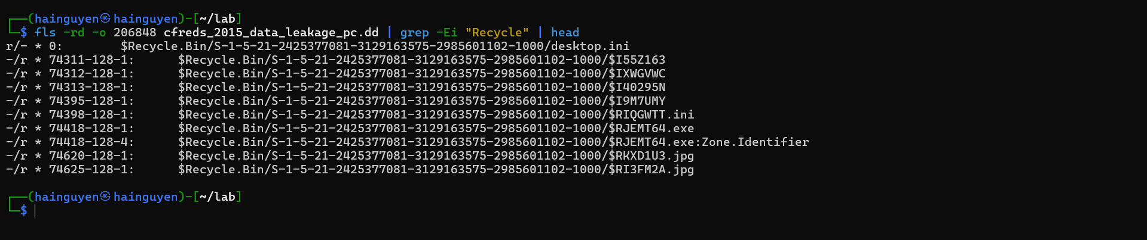
Step 2.
- Use testdisk to Recover $Recyle.bin
Recover the image

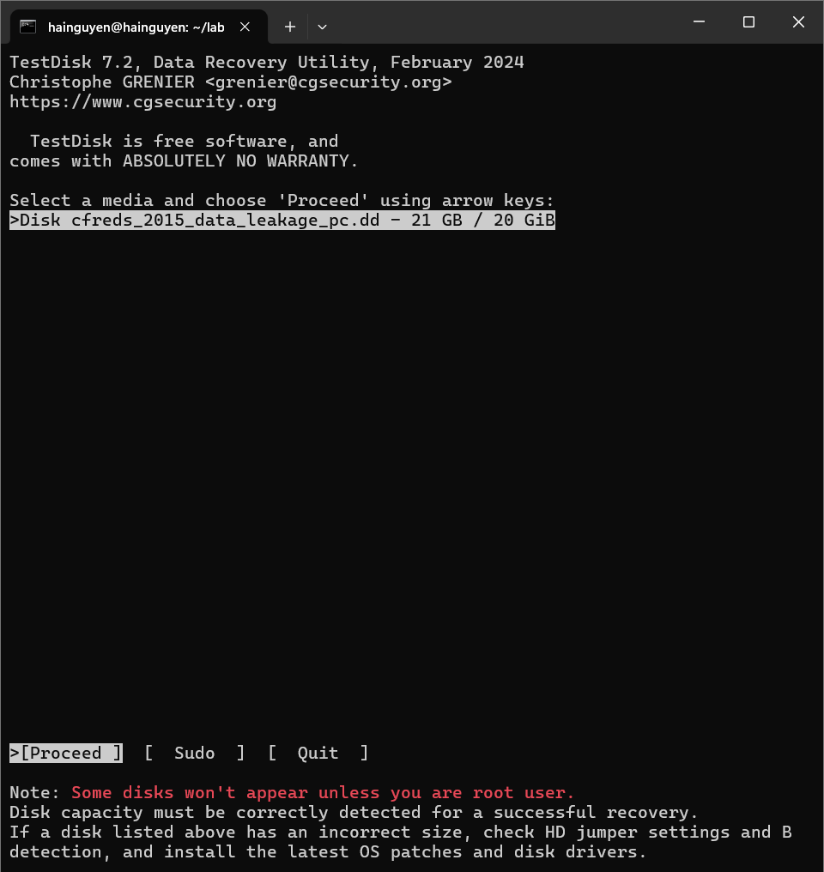

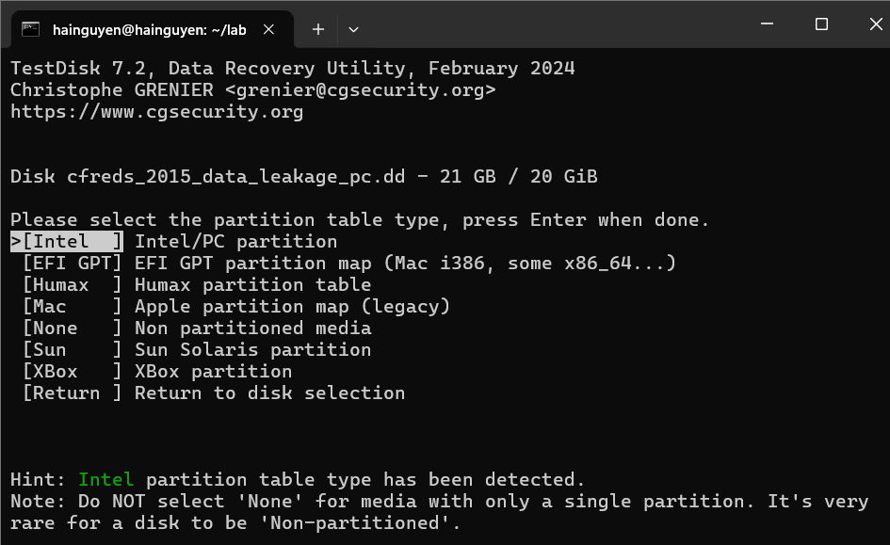

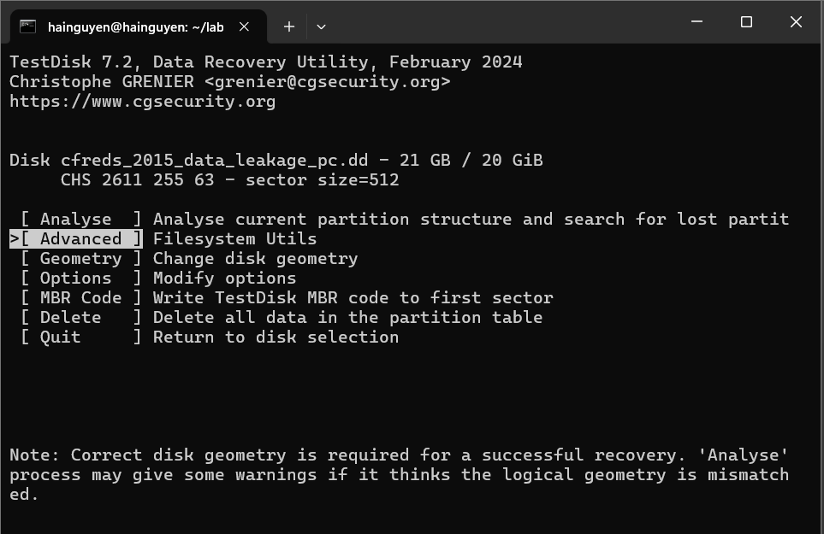

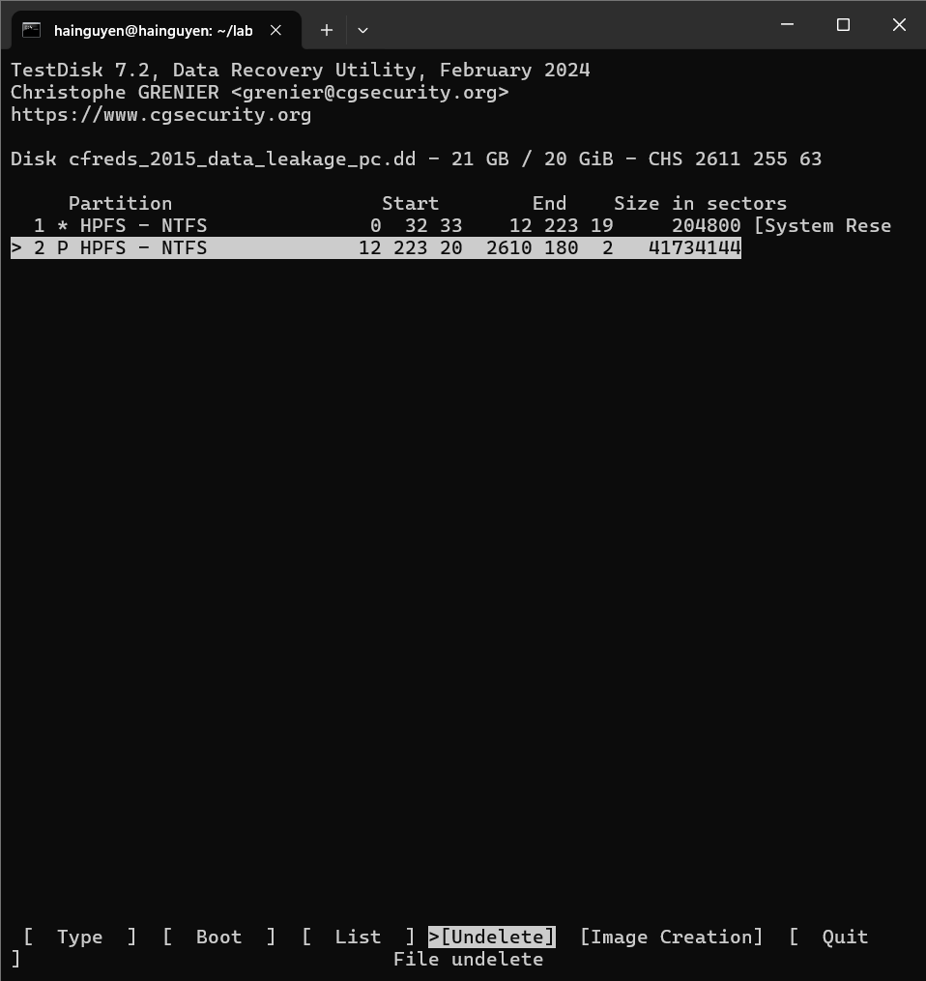

- Use testDisk to recover files
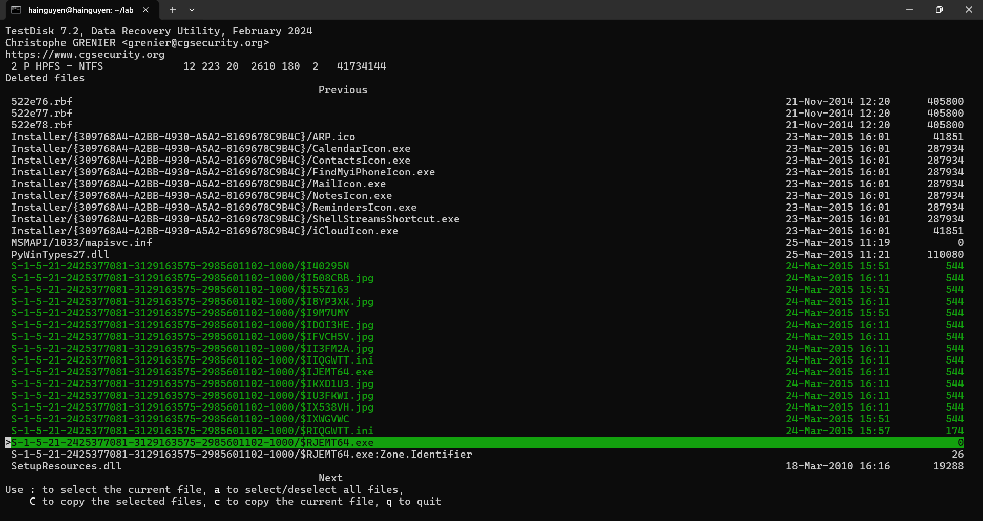
- Choose the destination and copy
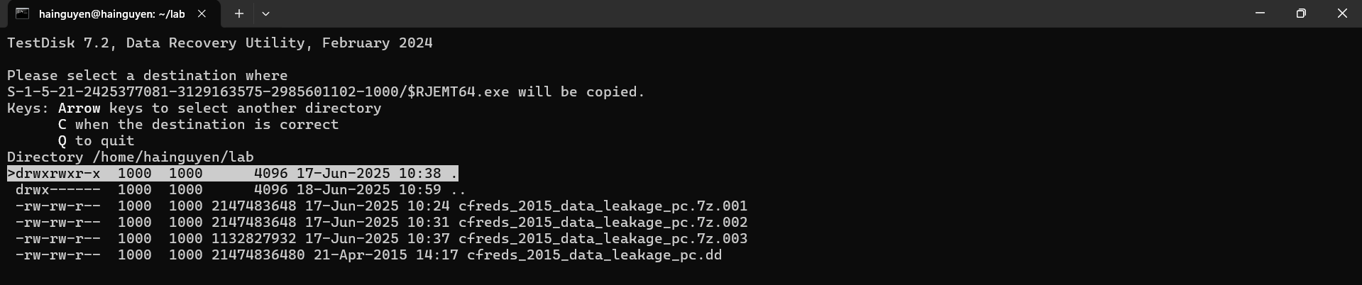
Quit all
ls S-1-5-21-2425377081-3129163575-2985601102-1000/ -l
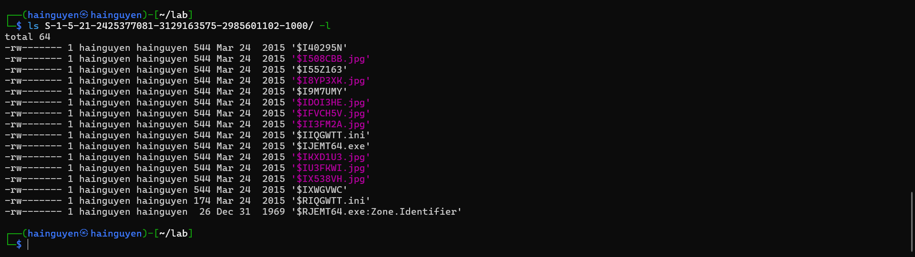

- Match random file names with readable file names in the file
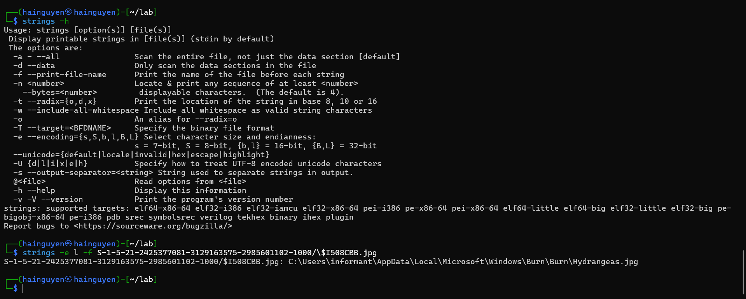
Examine ‘Recycle Bin’ data in PC :
$I Name | Timestamp Deleted | Original File (or Directory) Path
$I508CBB | 2015-03-24 15:51:47 | C:\Users\informant\AppData\Local\Microsoft\Windows\Burn\Burn\hydrangeas.jpg

- What actions were performed for anti-forensics on PC at the last day ‘2015-03-25’?
Step 1.
- Search IE anti-forensics using keyword
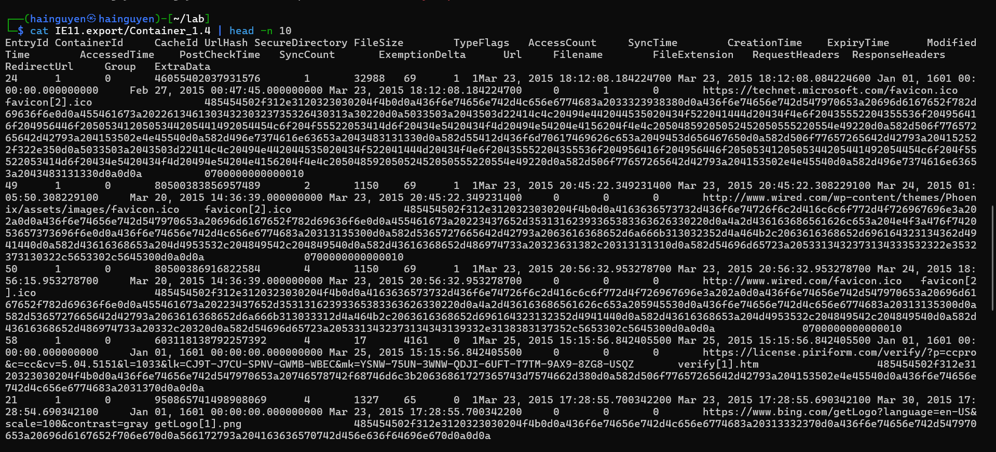
Three tasks:
- Show all IE history
- Grep date and with key word “anti”
- Highlight anti in red
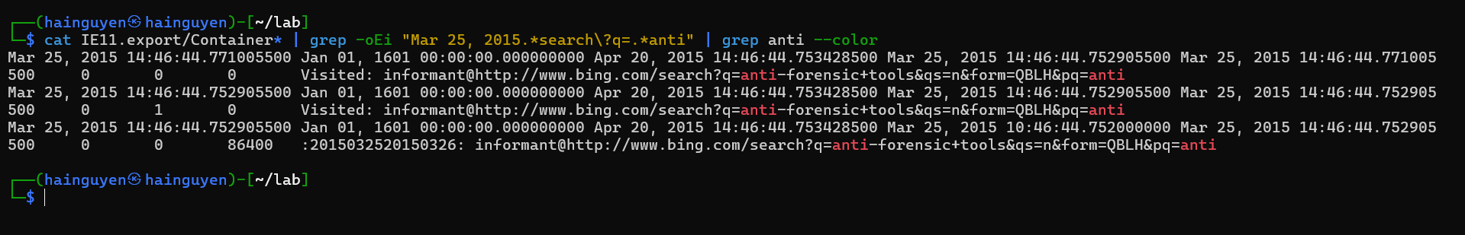
- Search a list of anti-forensic keywords :
cat webhistory/IE11.export/Container* | grep -oEi "Mar 25, 2015.*search\?q=.*(steganography|encryp|cover|log|diable|trace|cover|remove|overwrite|destroy|clean)"
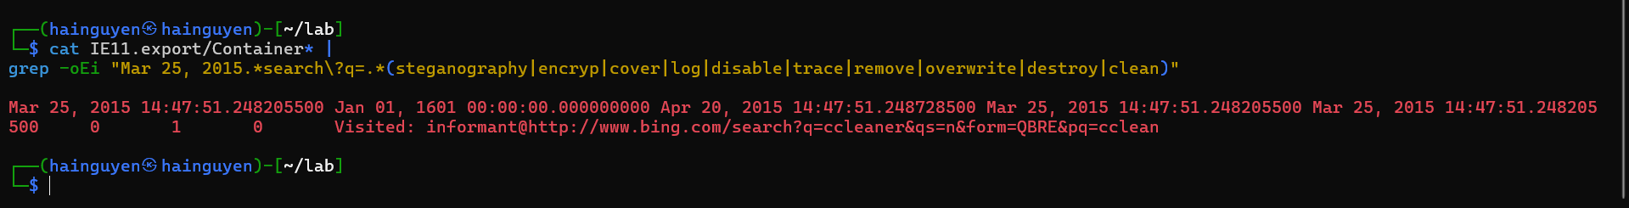
Step 2.
- Search IE download history
Search key word “download”, only show first two records for the demonstration purpose :
cat webhistory/IE11.export/Container* | grep -oEi "Mar 25, 2015.*download" | head -n2 | grep download --color
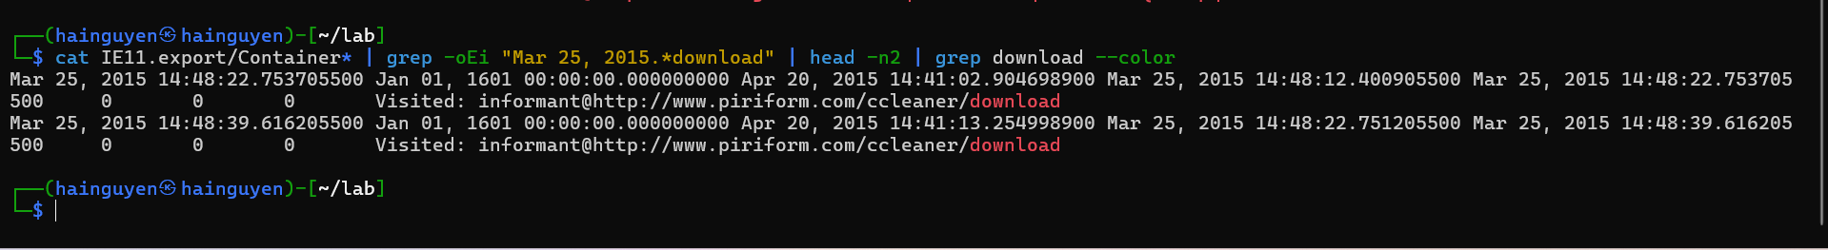
- Search key word “download”, only show last four records for the demonstration purpose
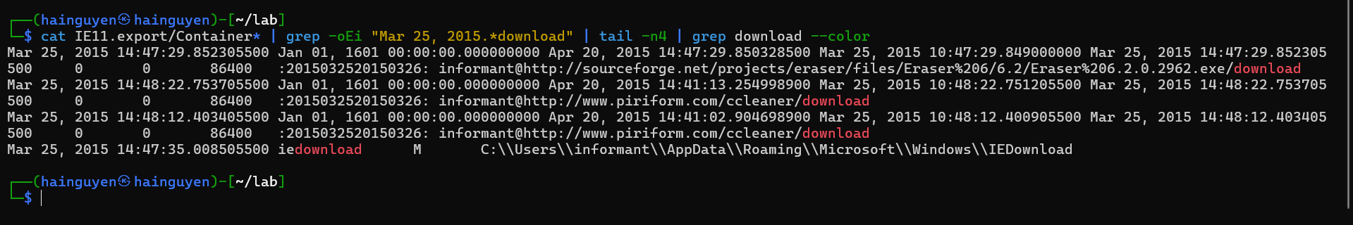
Step 3.
- Install download programs- shimcache
Check shimcache to monitor executed programs
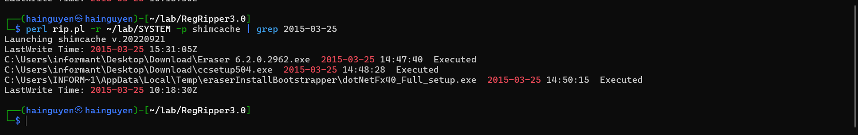

- Check if eraser or cclearner is managed by Win installer
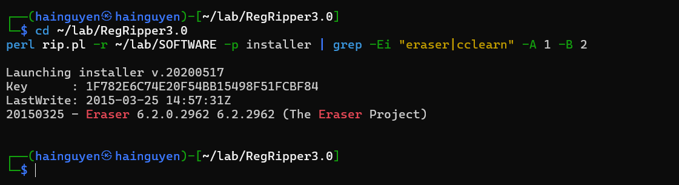
- Check Software registry hive
rip.pl -r SOFTWARE -p uninstall | grep 2015-03-25 -A 2 -B 2
rip.pl -r NTUSER_informant.DAT -p uninstall | grep 2015-03-25 -A 2 -B 2
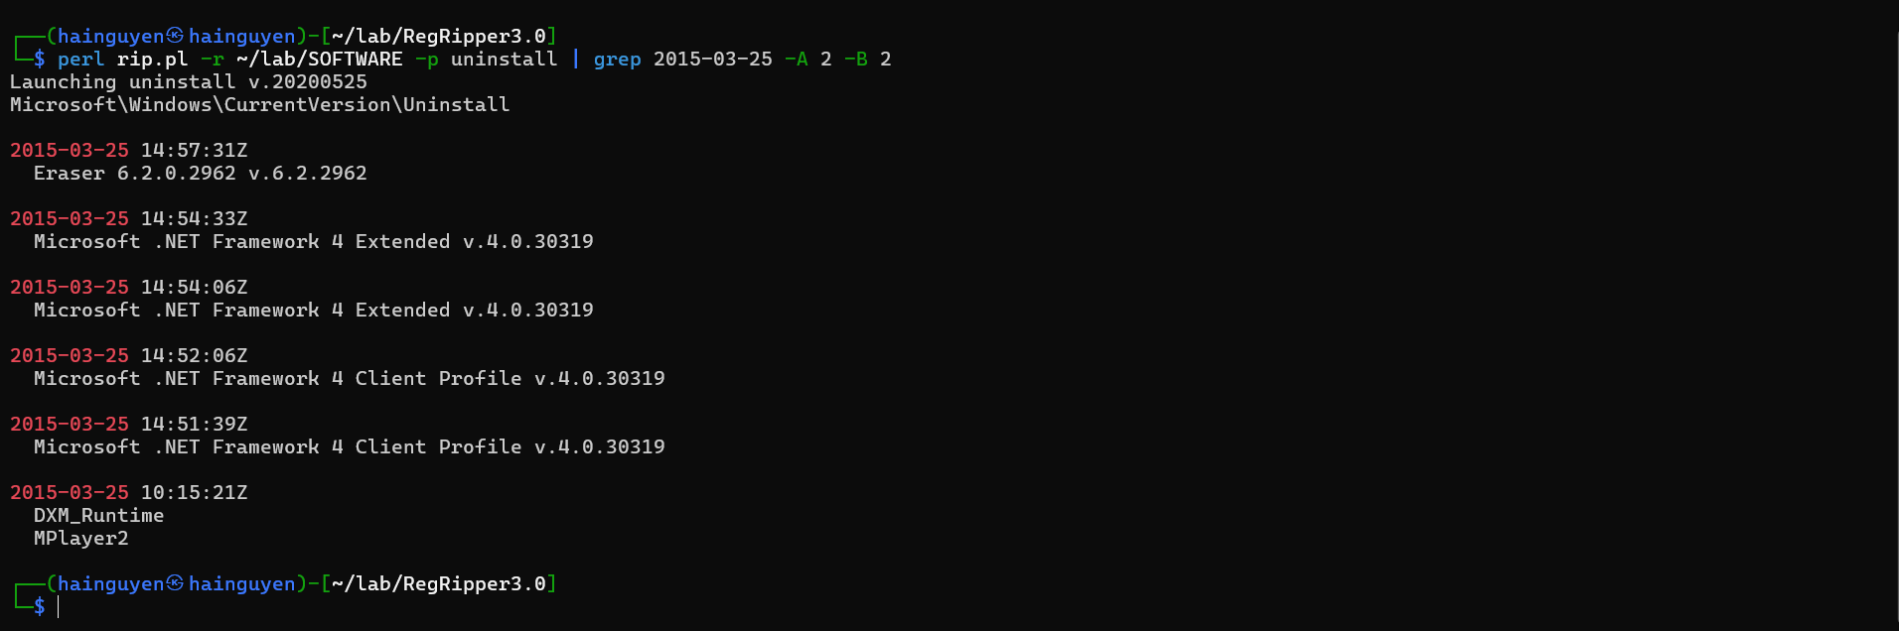
- Check NTUSER_informant.DAT registry hive
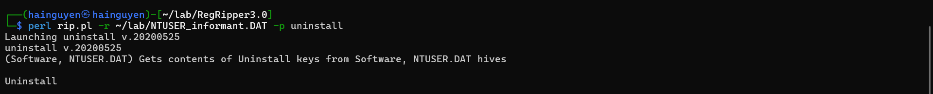
Nothing found
- Check app paths registry
Check Software apppaths
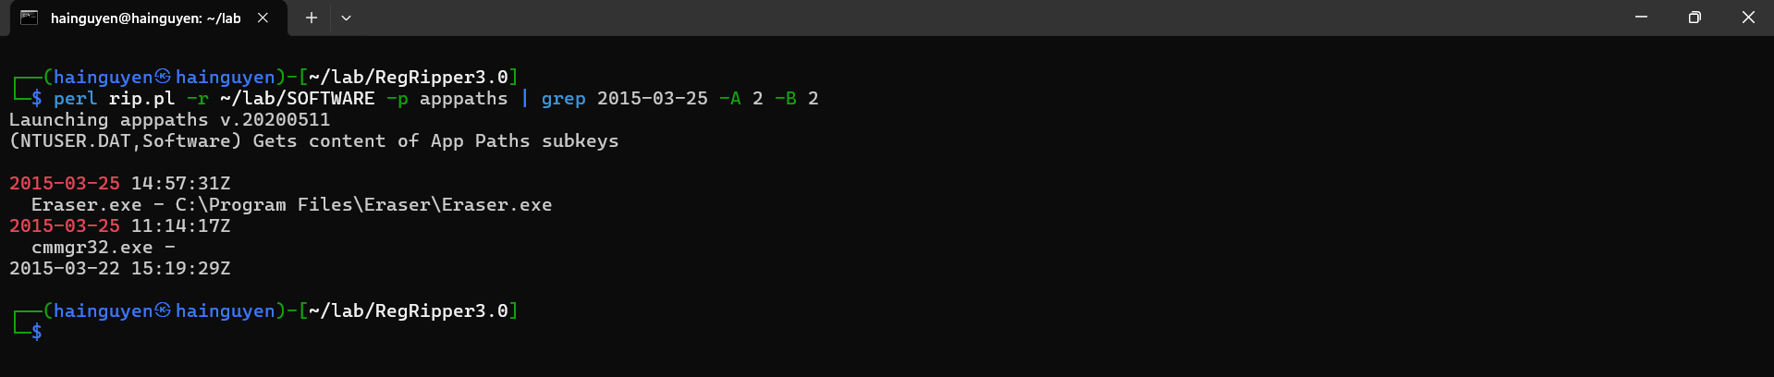

Check NTUSER_informant apppaths
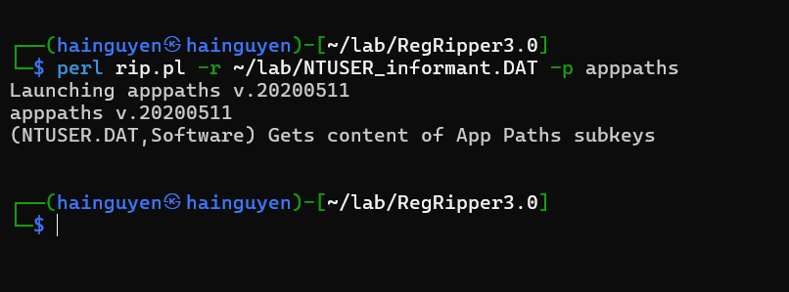
Step 4
- Execute two programs : userassist
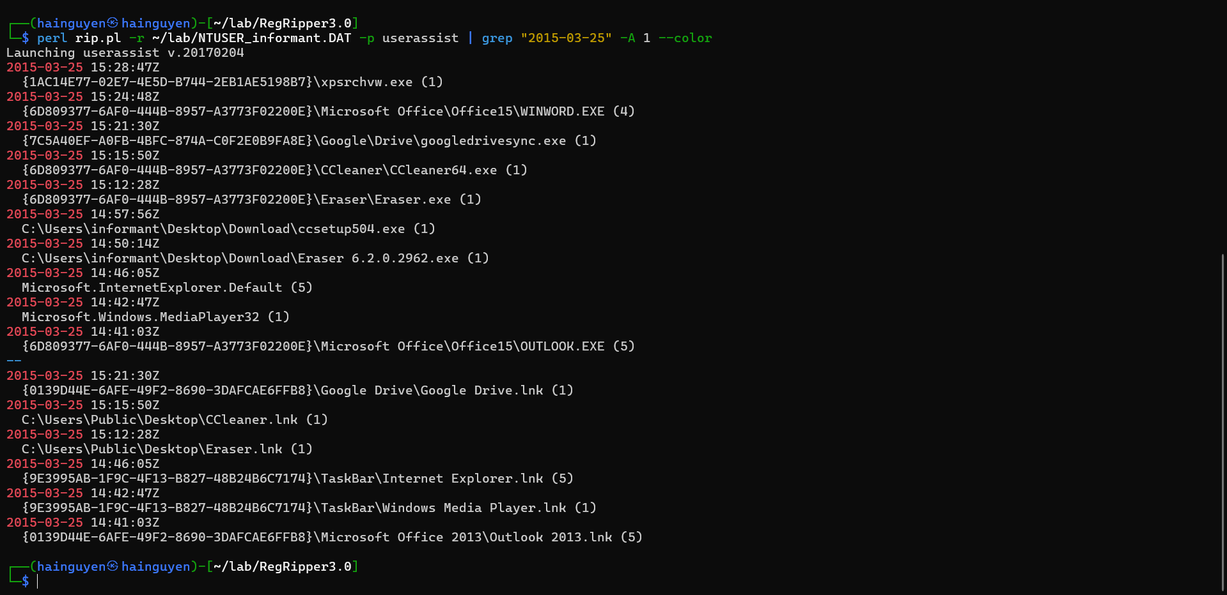
Step 5
Search for deleted .exe files
Only search for 2015-03-25 from Download folder
fls -rd -o 206848 cfreds_2015_data_leakage_pc.dd -l | grep -i Users/informant/Desktop/Download/ | grep 2015-03-25 --color

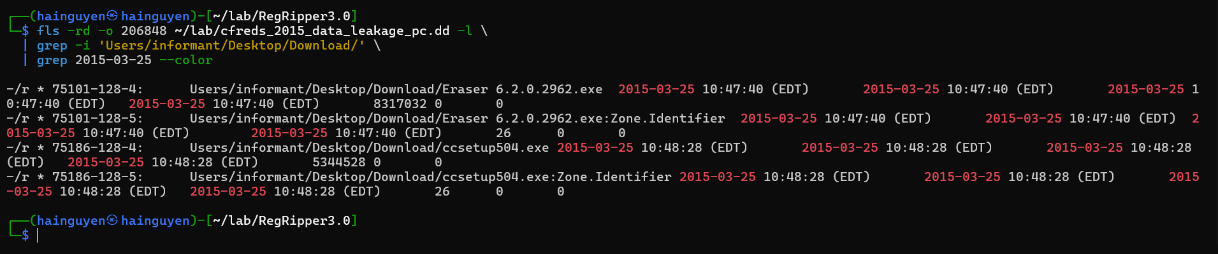
- Only search for deleted .exe from $UsnJrnl on 2015-03-25
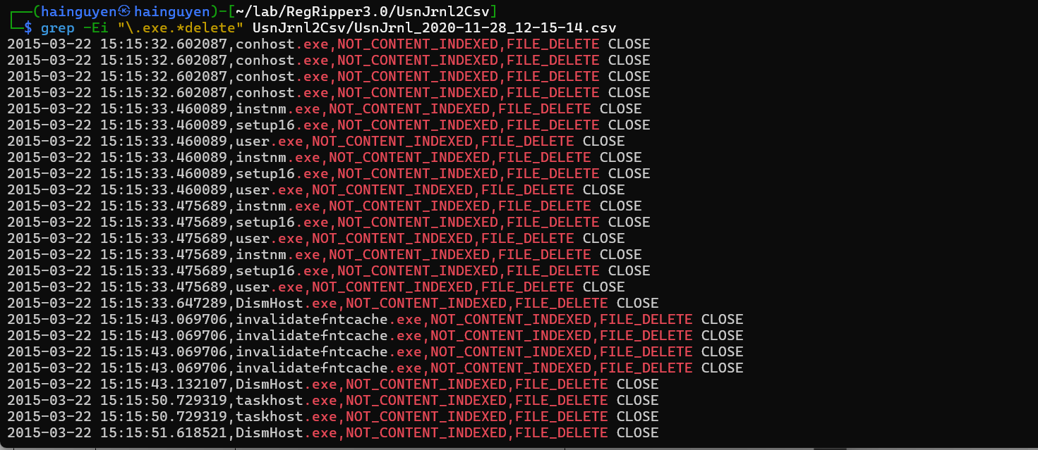

What actions were performed for anti-forensics on PC at the last day ‘2015-03-22’?
Timestamp | Behavior | Description
2015-03-22 15:15:32 | File Deletion | Nhiều bản ghi cho conhost.exe bị xóa – có thể là che giấu trình vỏ lệnh
2015-03-22 15:15:33 | File Deletion | Các file như instnm.exe, setup16.exe, user.exe bị xóa
2015-03-22 15:15:33 | File Deletion | Các file bị xóa nhiều lần, có thể dùng nhiều kỹ thuật để chắc chắn xóa sạch
2015-03-22 15:15:33 | File Deletion | DismHost.exe bị xóa – đây là công cụ quản lý ảnh hệ điều hành
2015-03-22 15:15:43 | File Deletion | invalidatefntcache.exe bị xóa nhiều lần – có thể là công cụ được giả lập
2015-03-22 15:15:50 | File Deletion | taskhost.exe bị xóa – là host cho tiến trình Windows task

YOU MUST SUBMIT A FULL-SCREEN IMAGE FOR FULL CREDIT!
Save the document with the filename "YOUR NAME Lab 7.pdf", replacing "YOUR NAME" with your real name.
Email the image to the instructor as an attachment to an e-mail message. Send it to: xxx@fe.edu.vn with a subject line of "Lab 7 From YOUR NAME", replacing "YOUR NAME" with your real name.

